EXPERIMENT 2
LINUX BASIC COMMANDS - II

Done By: Rohit Karunakaran
Roll No : 58
Date of submission: 14-5-2021

Exerise 1:
Send output of date command to already exist file

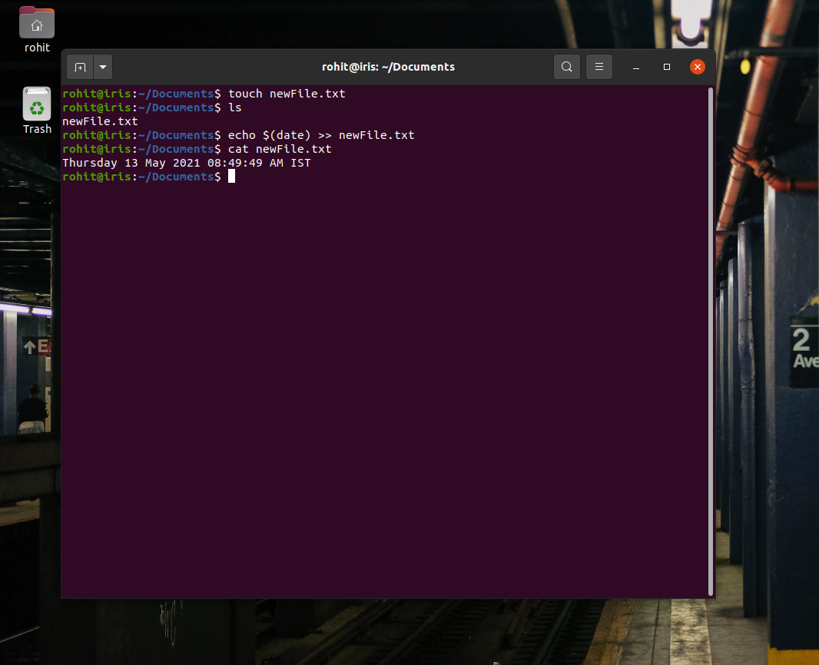

Exerise 2:
Encrypt the text in a file and display it

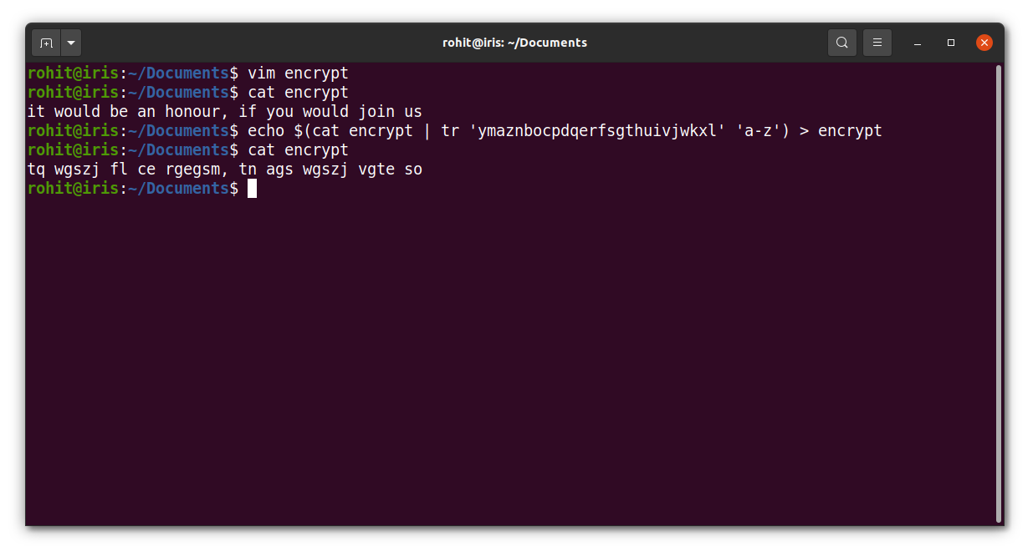

Exerise 3:
Create a file sample and give 5 names init. Display only the lines that does not contain the
character ‘a’, but the result should be in reverse order.

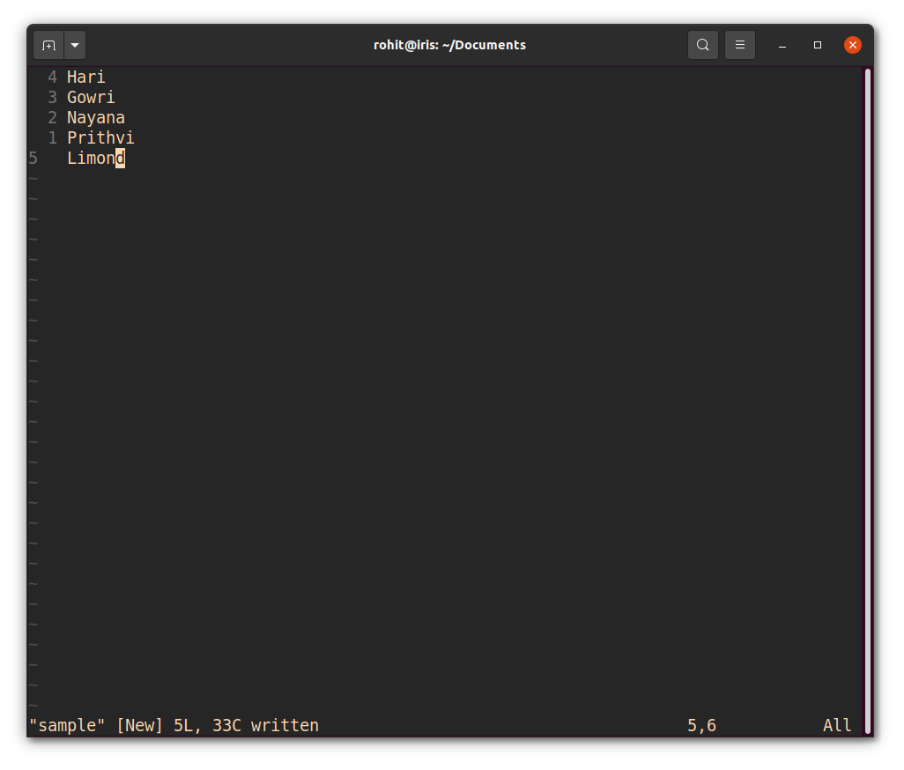

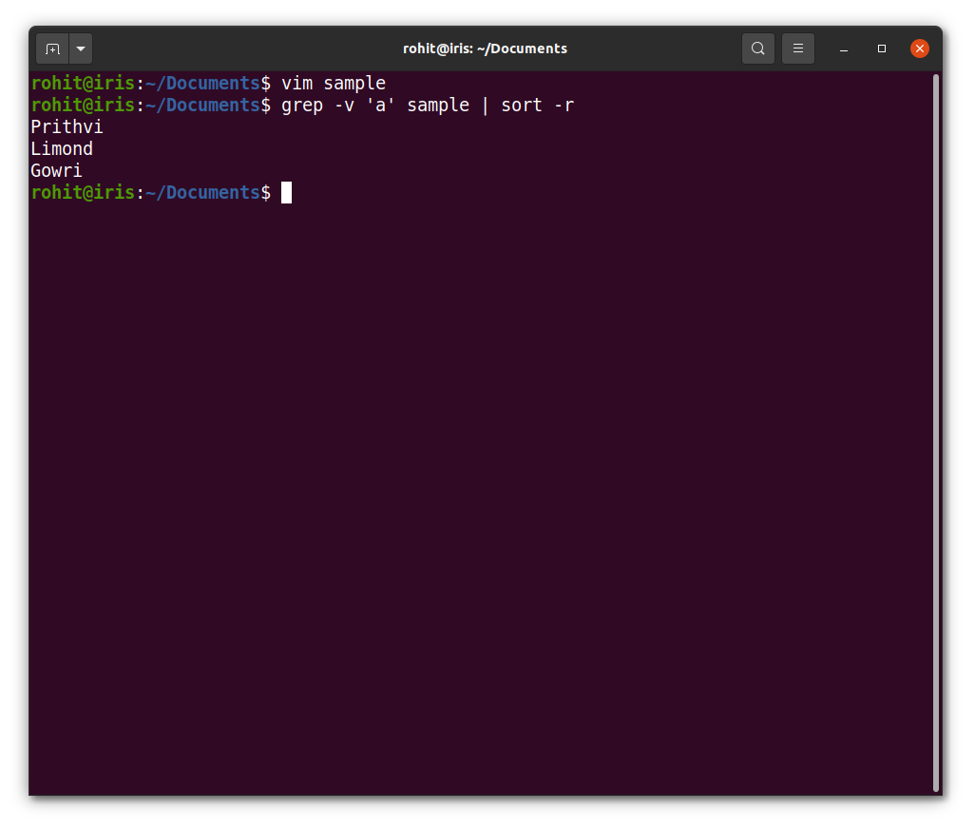
Exersie 4:
Write a command to give write and execute permission on a file

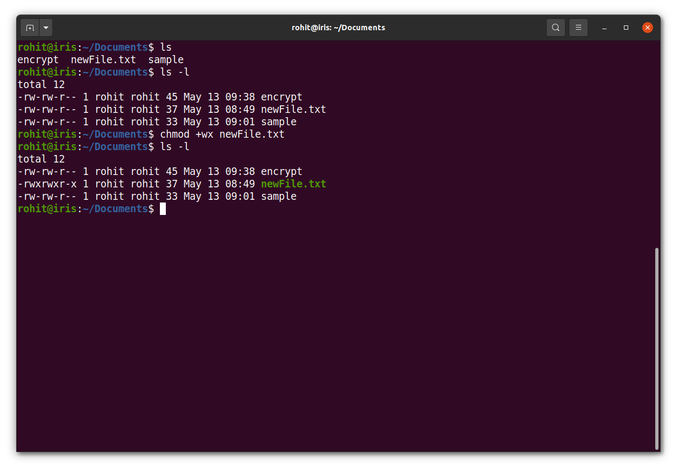

Exerise 5:
Write a code to list all current running processes their corresponding pid

